Scaly-sided Merganser task force. Update to the East Asian – Australasian Flyway Partnership MoP10

Dr. Diana Solovyeva & Dr. Baz Hughes, 01 October 2018

Introduction
The Scaly-sided Merganser is listed as “Endangered” by IUCN and is listed in the national Red Data Books of Russia, China, and South Korea. Most of the population breeds in the Far East of Russia, and winters in South China, South and North Koreas, and sometimes Taiwan. The reasons for the decline between the 1960s and 1980s included habitat loss due to logging of the flood-plain forests, illegal shooting and by-catch in gill-nets. Since the late 1990s numbers on the breeding grounds in Primorye, Russia, have stabilized and the world population in spring is now estimated as 4,600 individuals (Solovieva et al. 2014). The current threats to the population are illegal shooting and by-catch in gill-nets on the breeding grounds and damming of rivers on the wintering grounds.

Progress since last MoP9

Task Force Meeting and International Symposium
A Task Force Meeting and Scaly-sided Merganser International Symposium is planned for pre-MOP10 days on 5-8 of December 2018 in Changsha, China. Facilitated by the Bejing Forestry University, the workshop was attended by a total of ## participants from the Russian Federation, People’s Republic of China, Republic of Korea, the UK, and the EAAFP Secretariat including Task Force members working on both in and ex situ conservation. The Scaly-sided Merganser International Symposium was attended by 150 participants primarily from China. The workshop was followed by a one-day field excursion to the Yanalushi River.

Action Plan
The Single Species International Action Plan was submitted to CMS for approval. A schedule of National Action Planning Workshops (Russia, China, South Korea) will be developed during the Task Force Meeting on 5-8 of December 2018.

Task Force Operations
The Scaly-sided Merganser Task Force now numbers 20 members and eight consultants. Task Force members work on both in and ex situ conservation. Funding of small conservation projects became regular on an annual basis after we developed an application and evaluation processes. Funds for small grants were provided by Zoos associated in WAZA, ARAZA, and EAZA.

Conservation Initiatives on a Local level
The Scaly-sided Merganser is recognized as one of the four key species (Scaly-sided Merganser, Oriental White Stork, Siberian Crane and Amur Tiger) in the ‘strategy plan’ of the Forestry Department of Jilin Province, China. At the beginning of May 2018, a workshop for a specific campaign for SSM in Jilin Province was facilitated by Forestry Department of Jilin Province and in full (JPWCA). Delegates from more than fifteen different Forestry Bureaus participated in the workshop and introduced the situation with Scaly-sided Merganser in each Forestry Bureau.

Breeding Population Dynamics in Russia and China
The Scaly-sided Merganser population in the Kievka River study area has been largely stable at around 40-60 pairs since the study began in 2000 (Figure 1).

Figure 1. Numbers of Scaly-sided Merganser breeding pairs and broods in the Kievka River catchment, Primorye, Russia.

Large-scale Surveys on the Wintering Grounds in China
A total of 2,019 people took part in the surveys in 2014-16. Most of the participants were from 102 bird watching societies, universities and institutes, or relevant organizations with basic background of field work and bird watching. All volunteer observers were trained to identify M. squamatus,
especially from Common Merganser M. merganser or Red-breasted Merganser M. serrator. The distance from the south to the north was c. 2,600 km and east to west c. 2,400 km. In total, 441, 634 and 1,138 individuals were recorded in winters of 2014, 2015 and 2016, respectively (Qing et al. 2018). Surveys were continued in 2017-18.
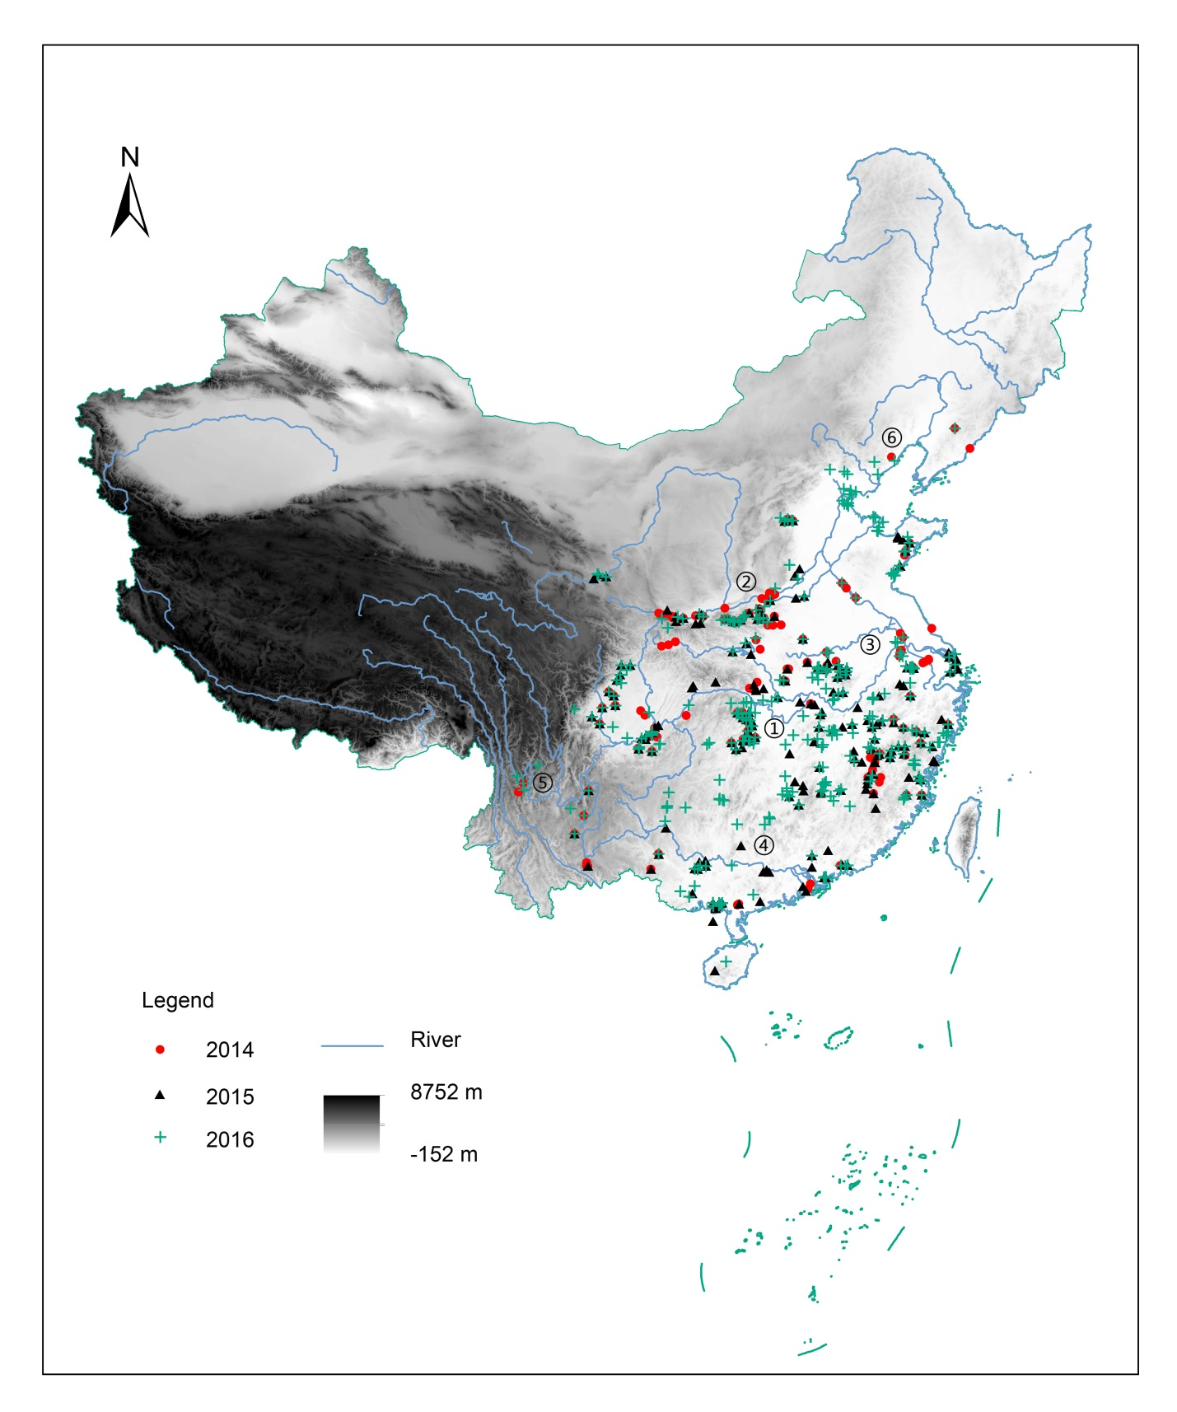
Figure 2. The citizen science Scaly-sided Merganser wintering survey sites in winters 2014–2016. 1 Yangtze River, 2 Yellow River, 3 Huaihe River, 4 Pearl River, 5 Lancang River, 6 Liaohe River (Qing et al. 2018)

Artificial Nest Box Programme
Three active “incubators” in the Primorye – the Kievka River basin, the Avvakumovka River, and the Zhuravlevka River produced between 227 and 287 ducklings in 2017 and 2018, making a total of 1,449 to 1,910 since the project began. The nest box campaign continues to be successful in Changbaishan Mountains in China and unclear results were provided by Bishui Nature Reserve (Lesser Xingan Mountains). Video monitoring of nest boxes in Russia helped to reduce hen disturbance during incubation via remote control of nest boxes. All artificial nest sites in the Kievka River catchment were equipped with remote sensing video-cameras. Nesting biology was investigated over 17 years (2001-2017) in both artificial and natural nest sites in the Primorye. A total of 205 nests were recorded: 190 nests in artificial sites and 15 in natural cavities. Occupation rate of nest boxes (27.8%) was significantly higher than of nest tubes (20.2%). Clutch size averaged 11.08 ± 0.05 (n=145) eggs. Inter- and intraspecific nest parasitism was described and the effect of parasitism on nest success was evaluated. Advanced clutch onset during the study period was significant. Apparent nest success (70.4 ± 4.0 % - proportion of nests producing at least one young) was independent of cavity type, with no significant difference between artificial and natural sites.

Information and Education
On 19 April, 2018, at the ceremony of ‘Bird Loving Week’ (Bird Week) of Jilin Province, a specific campaign was launched by the Forestry Department of Jilin Province. JPWCA, Northeast Normal University and WWF China signed an agreement on conducting the conservation program jointly for SSM in Jilin Province.

A new leaflet was created, 2,000 copies were printed and distributed amongst local people within the entire breeding range in Russia. The leaflet highlighted range overlap with Amur Tiger and promoted conservation of habitats for both species of concern.

PLAN FOR THE PERIOD TO THE NEXT MOP

- Hold National Action Planning Workshops and accept National Action Plans for China, S Korea and Russia.
- Investigate genetic diversity of birds from captive and natural populations.
- Complete the Scaly-sided Merganser Field Station in Kishinevka village and use it for education
- Continue main activities such as surveys on the wintering grounds, monitoring of breeding population, artificial nest programme, study of nest success and productivity.
- Repeat surveys for the world population estimate.

