MOP9 Interactive Sessions

Session 1: A Vision for the Flyway and the Flyway Partnership

Session 2: Achieving better Engagement in the Partnership and Beyond

1. Introduction
Two interactive sessions were held at MOP 9 involving almost all participants. The sessions were designed to collect views about the Flyway and the Partnership that might help inform the development of the next Strategic Plan for the Flyway Partnership but also to help participants appreciate their common aims and understand their diversity in specific goals, skills, capacities, and work environments.

Session 1, A vision for the Flyway and the Flyway Partnership, required participants to imagine the Flyway in 10-15 years from now after the implementation of a new Strategic Plan. Participants worked within their implementer groups (Government, INGO, Scientist, IGO, or Secretariat). Four small groups of five people produced a drawing of what the Partnership or the Flyway would look like in this timescale – no words, just pictures. The remaining seven groups, each with around 10 participants, were tasked with describing what the EAAFP would look like within this timescale.

Session 2, Achieving better engagement within the Partnership and beyond, looked at key implementation activities that are not been delivered by participants yet are key elements of successful implementation. Essentially, what are you not doing now that is important for Flyway implementation and why are you not doing it? Participants worked in mixed implementer groups for this exercise.

The complete data sets from the two sessions are available in the document MOP9_InteractiveSessions_Annexes

2. Session 1: A Vision for the Flyway and the Flyway Partnership

2.1 The Groups and the Tasks
Participants were divided into their implementer groups (Government, INGO, Scientist, IGO, Secretariat)

Groups 1-4
Each group included five people: two groups were made up of INGOs, one group of Government representatives, and one group of IGOs
“A picture is worth a thousand words”
Develop an agreed vision of the Flyway and Partnership in 15 years’ time. Where will we be then? Armed with coloured pens and paper create two pictures.
Picture 1 – What will the Flyway look like? (Groups 1 & 2)
Picture 2 – What will the Partnership look like? (Groups 3 & 4)
No words – just pictures!

Groups 5-11
Groups included two Government, two INGO, one scientist, one Secretariat, and one IGO. Groups varied in numbers: Government, INGO, and Scientist groups included around 10 people, while the IGOs and Secretariat included only 4-5 people.

The Scenario
You have just completed 10 years successfully implementing a new vision and Strategic Plan for the EAAFP. A documentary team with a big budget is coming to you, the Flyway Partnership representatives, to discuss a video documentary on the positive progress you have made.

The Process
Sit together with your group. Work with a partner. Make a list on one or two post-its of what positive achievements you will share with the documentary team (15 minutes).
- Come together as a group and share your ideas (20 minutes).
- From your group discussions, agree on 6 concrete elements of this successful EAAFP and prepare a flipchart sheet to present your summary to everyone (20 minutes).
- Here are some questions to stimulate your thinking on what you might share with the documentary team:
What will you show them? What activities/results will they see? What are your key achievements? What new collaborations have there been? Etc.
4. Each group will briefly present their flipchart summary to a plenary session.

2.2 Results
Groups 1-4. The four drawings are shown below. Drawings one and two depict what the Flyway will look like in 10 years’ time while pictures three and four depict what the partnership will look like. Not all pictures were fully completed due to lack of time.

1. GROUP 1 INGO The Flyway 10 years from now | 2. GROUP 2 INGO The Flyway 10 years from now
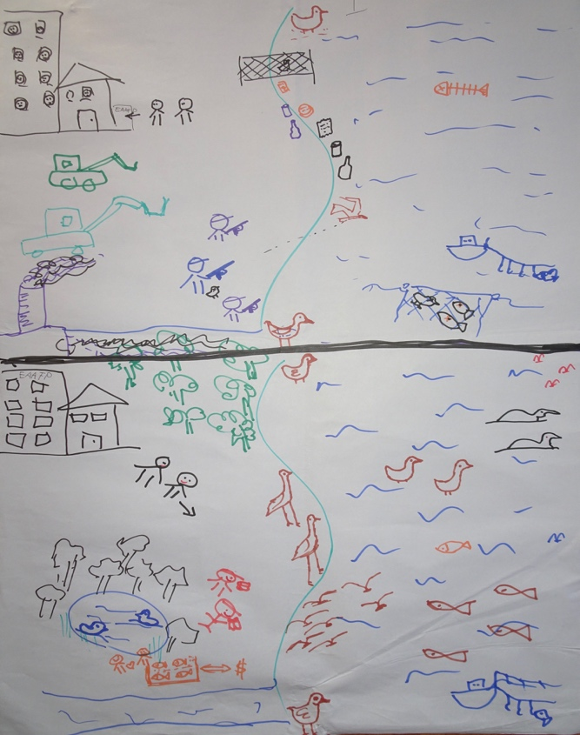 | 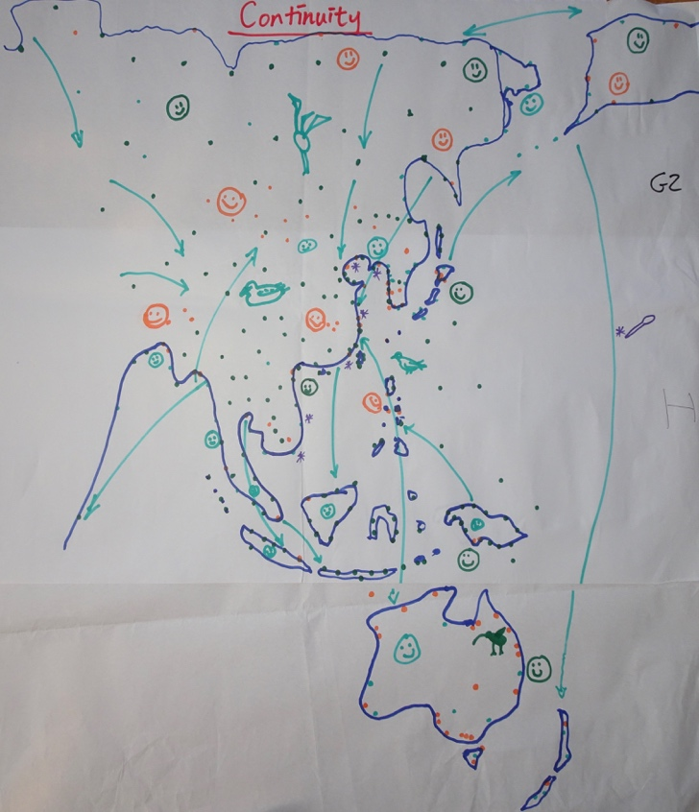

3. GROUP 3 GOV The Partnership 10 years from now | 4. GROUP 4 IGO The Partnership 10 years from now
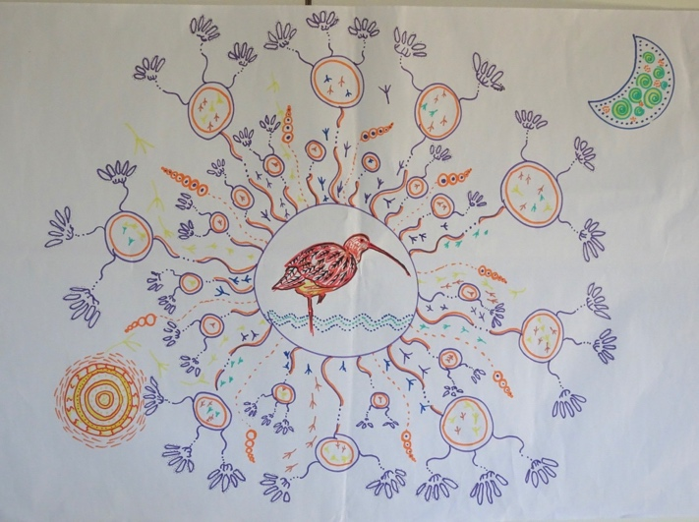 | 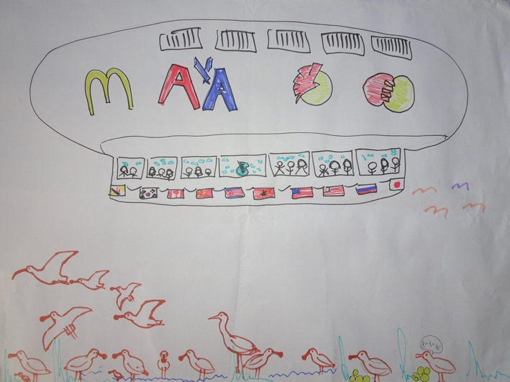

Groups 5-11.
General observations on the group approaches to the task: (i) not all groups worked in pairs for step one as requested so it was not clear whether the post-its were produced by one or two people; (ii) while all groups provided a detailed flipchart sheet on their collective conclusion, two groups did not provide any post-its and others did not provide all post-its.

2.3 General points and Conclusions:
It is important to note that the sub-group responses (usually representing the views of one or two participants) often provided more broad-ranging indicators of ‘success’ than the agreed group response. This is not surprising given the diversity of experience and working environments of the implementers within each group. This diversity is important in recognising the need for, and benefits of, collaboration and information-sharing across and within implementer groups within the Partnership. Table 1 and the bulleted comments below are based on the group responses since not all post-its were available from all groups. Note that there is some unavoidable overlap across the groupings in Table 1.

Table 1 Analysis of the presentations, groups 5-11
Where the successes were noted | Group 5 | Group 6 | Group 7 | Group 8 | Group 9 | Group 10 | Group  11 | Sub-Totals | Totals
Knowledge improvement |  |  |  |  |  |  |  |  | 15
Data: Adequate Data, including mapping species, populations migration routes etc. |  |  | 1 | 1 | 1 | 1 | 1 | 5
Monitoring and Data-sharing/collaboration | 1 | 1 |  |  | 1 | 1 | 2 | 6
General Knowledge improved/ exchange among scientists/sites/countries | 2 | 1 |  |  | 1 |  |  | 4
Engagement of people improved |  |  |  |  |  |  |  |  | 13
Local - site support from local communities |  |  | 1 |  |  |  | 1 | 2
Support from general Public/local people through good education materials/programmes/events for children and/or adults | 1 | 1 | 1 |  | 1 | 1 | 1 | 6
Capacity building (various targets) |  |  |  |  |  | 1 |  | 1
Sister sites/linked communities | 2 | 1 |  |  |  |  | 1 | 4
Site Management improvement |  |  |  |  |  |  |  |  | 12
Management plans and implementation for more/all sites/participatory in some cases | 1 | 1 |  |  |  |  | 1 | 3
Legislation/regulation/policy for site protection |  | 1 | 1 |  |  |  | 1 | 3
Local people involved in site management |  | 1 |  | 1 |  |  |  | 2
Livelihood improvements for local people |  | 1 |  |  |  |  | 1 | 2
Successful site restoration |  |  |  |  | 1 |  | 1 | 2
Flyway Network Site (FSN) development |  |  |  |  |  |  |  |  | 4
More Flyway Network Sites (FNS) designated | 1 | 1 |  | 1 | 1 |  |  | 4
Funding enhanced |  |  |  |  |  |  |  |  | 2
Adequate funding available |  |  |  | 1 |  |  | 1 | 2 | 2
 |  |  |  |  |  |  |  |  | 48

Some specific comments on the results:
- Knowledge improvement and sharing included adequate monitoring, mapping, data management, and knowledge exchange mechanisms and was mentioned by six of the seven groups; not surprisingly the more detailed focus on this area in the group results came from the scientists.

- Effective engagement programmes (through awareness, education, capacity building programmes) were identified by almost all groups as important, acknowledging the link between these and better stewardship. Identified key targets included adults, children, and local communities.

- Site management elements were also broadly recognised as essential components of success. Only two groups specifically mentioned ‘livelihoods’ in this context. This was also true across the available post-its.

- Networking of sites and/or managers at national and international levels were identified by four of the seven groups.

- Only four of the seven groups identified the importance of designation of more sites to produce a robust network.

- Funding was not broadly recognised in this visioning exercise as a key contribution to successful implementation. It is perhaps rather surprising that only two groups mentioned adequate funding as part of the success story. (Note that in Workshop 2, while the lack of funding was not identified as a key task that participants thought they should be doing it was identified as a main factor in non-delivery of their key tasks).

Broad conclusions
While there were many similarities in the key areas of ‘success’ identified by the groups there were some contrasting responses as noted above. It will be important to ensure broad implementer representation during the development of the next strategic plan so that the breadth of knowledge and understanding of implementation challenges across the Partnership are adequately reflected in the next plan.

3. Session 2: Achieving better Engagement in the Partnership and Beyond

3.1 Introduction

This session looked at key implementation activities that are not been delivered by participants yet are key elements of successful implementation. Essentially, what are you not doing now that is important for Flyway implementation and why are you not doing it? Participants worked in mixed implementer groups for this exercise.

3.2 The Groups and the Task
i. Nine groups took part in Workshop 2 with each group including a mix of implementers. All groups included Government and INGO implementers, eight included Scientists, four included IGO representatives and five included Secretariat staff (see Session II, Annex I).

ii. The task began with each group member answering two questions on a coloured post-it, the colour reflecting their implementer group:

Question 1
What should you do now that is important for improving Flyway implementation. This is something that you have not done before but that you know needs to be done to bring about positive change in implementation.

Question 2
Why are you not doing it now (e.g. lack of time because of other priorities, lack of budget, lack of personal or colleagues’ capacity, lack of help from colleagues, lack of understanding from colleagues of importance of tasks etc.). Be specific.

iii. Following step ii group members came together to discuss their individual results and collectively produce a poster of their agreed conclusions to share in a plenary session.

3.3 Results
The posters and the associated post-its provide information on the key needs identified by the nine groups of mixed implementers through the poster presentations, as well as the range of individual implementer answers. Both the individual and collective responses are important in the analysis; the former may show any differences between implementer groups while the latter may show more of a partnership view. A summary of the group flipcharts and the individual post-its within each group are recorded in Session II, Annexes I, II and III.

i. Group Responses. The group discussions produced a range of key topics on their flip charts. A review of these topics has looked for common themes across the groups and produced the following key areas from the group discussions; other configurations are of course possible.

Knowledge
- Scientific knowledge about species, the Flyway, the Sites
- Effective monitoring to gather essential data about species
- Site manager capacity– through management training and capacity-building, technical knowledge & communication skills
- About the Flyway, the Flyway Network Site (FNS), new sites in-country etc., within governments from national, to regional and local levels.

Engaging people (outreach/CEPA) – those already involved to some extent in the Flyway and those who need to be engaged for the first time, and how they should be engaged:

Who needs to be engaged? | How to engage these target groups?
Site managers, local communities, general public, children and young adults, Implementers within national, regional and local governments, corporates, EAAFP Secretariat & Partners | Increasing awareness of and information about the Flyway and migratory species through stories, information & interpretive materials appropriate for the target group, special events, meetings, campaigns etc.
Partnerships/Networks
- Sister sites; in-country and cross-country site manager networks to enhance sharing of knowledge and know-how

Developing the FSN
- Identifying and designating more FNS across the Flyway
- Active support from national, regional and local governments for Flyway development and maintenance

Funding
- Needed at all levels within the Flyway, for awareness-raising, scientific work, site management etc.
- Corporate sector engagement and funding support
- Voluntary funding

ii. Individual responses. These have been grouped in the Table 2 below using the categories identified above and the implementer type (whether Government, INGO, Scientist, IGO or Secretariat). Table 3 shows a re-grouping of one of the categories. The full details of the grouped individual responses are recorded in Session II, Annex II.
Table 2  Categories | Totals | Gov | INGO | Scientist | IGO | Secretariat
KNOWLEDGE | 25 | 10 | 4 | 9 | 2 | 0
Data Management | 9
Monitoring | 7
Personal Development | 3
Other | 6
ENGAGING PEOPLE | 25 | 9 | 9 | 3 | 2 | 2
Local | 8
National/regional | 6
Supra-national | 5
General | 6
PARTNERSHIPS | 6 | 2 | 1 | 1 |  | 2
Sister Site development | 1 | 1
Site/Site Manager Networks | 5 | 1 | 1 | 1 |  | 2
DEVELOPING THE FSN – More sites | 4 | 2 | 1 | 1
FUNDING | 7 | 2 | 4 |  |  | 1
Grand Totals | 67 | 25 | 19 | 14 | 4 | 5
Percentage of respondents | 100% | 37% | 28% | 21% | 6% | 7%

Table 3 | Totals | Gov’t | INGO | Scientist | IGO | Secr’t
ENGAGING PEOPLE
Local people | 2 | 1 | 1
General | 5 | 1 | 2 |  | 1 | 1
Government | 5 | 4 | 1
Site Managers | 2 | 1 |  | 1
Partnership | 6 | 2 | 3 | 1
Private sector | 1 |  |  |  |  | 1

3.4 General Points and Conclusions:

A few notes/reminders about the data
- Note that we are looking only at the views of implementers who came to MOP. Not present were Site Managers and there were only two people from local/provincial governments. Also, while INGOs are well-represented this is not so for NGOs who may also be important as in-country implementers and may hold different views/approaches from INGOs.
- The group ‘scientists’ includes a few people who work within Governments and INGOs but essentially work as scientists.
- Remember that participants were asked what they as INDIVIDUALS were not doing that they knew they should do. They were NOT asked more broadly about gaps in implementation by other implementers.
- A few respondents recorded several tasks instead of one as requested. In these cases, the first task was used for the analysis.
- It has not been easy to categorise the responses in an informative and coherent manner and there are certainly other categorisations possible than those shown below.

Question 1 ‘What should you do now that is important for Flyway implementation?’
Knowledge gaps – The two key areas in this group, Data management/Science and Monitoring, together elicited more than two-thirds of the responses in this category. Not surprisingly the scientists were disproportionately represented in these two sub-categories. Data Management comments called for gathering essential migration data, improving databases, and analysing and use of this data for the benefit of the Flyway. Under monitoring there was, for example, an expressed need for monitoring networks, monitoring across neighbouring countries, and organizing a local monitoring group.

Within this grouping there were also three participants (from IGO, INGO and Government) who were new in their positions and felt that their personal knowledge about migratory birds was not adequate for their role and needed to be improved.

Engaging people: This group proved to be as important an area for development as the need to improve levels of knowledge with exactly the same number of entries. The target groups in Table 2 ranged broadly from local to national/sub-national to supra-national. The activity ranged from raising awareness about the flyway and migratory birds through campaigns, stories, communication materials, interpretive materials at sites etc. with the general public, local communities, local and provincial governments, the private sector such as construction companies and the EAAFP Secretariat. Table 3 above shows a re-grouping of this category according to target group and shows a focus on the public in general, the Government and the Partnership and low focus on the private sector and Site Managers.

Partnerships: This group included the need for more Sister Sites (only one vote and another not recorded from a respondent who mentioned several tasks), and more Sites and Site Managers networks (six respondents from all implementers groups except the IGOs identified this need).

Funding: Relatively few implementers (7) identified this as a task they should be involved in as a high priority.

Knowledge vs Engagement: From a broad look at responses, Governments seemed equally split in identifying Knowledge or Engagement as their key ‘task’ needed but not delivered while the INGOs were predominantly concerned about their lack of delivery in Engagement rather than Knowledge. In contrast, the Scientists’ key tasks not delivered were more likely to be concerned with Knowledge rather than Engagement. Given traditional roles of these three implementer groups, these are not surprising results and simply reinforce common precepts. Importance of this? It is very important to be working closely together as implementers to ensure all aspects of implementation are given the necessary attention.

ii. Question 2 ‘Why are you not doing this task?’
Many respondents mentioned more than one factor (see Session II, Annex III). Not surprisingly, most commonly mentioned was lack of time (32 times), followed by lack of funding (24 times), then lack of knowledge/capacity (15 times). Also mentioned was lack of the human resources to assist with the task; no interest/understanding from key people; not a priority; and lack of information/understanding as they were new to the EAAFP and still in the learning phase.

Broad Conclusions
In this task the different implementer groups had to work together and in doing so shared their views and ideas about the diverse needs within the Partnership to improve the health of the Flyway and its migratory species. This in itself is a useful learning process for implementers and an opportunity to broaden the understanding of implementation challenges and the need for effective collaborative management of the Flyway by all implementers for broad success. In addition, the results indicate some of the weaknesses in implementation, identifying gaps in terms of knowledge and engagement that need to be addressed. While the need for funding as a key challenge to effective implementation was clearly acknowledged, it is also clear that implementers at the MOP do not really see this as a key task for them personally to engage in. This emphasizes the need for a robust fund-raising plan recognising this as a specialist area that is not core to the work of many implementers.

