Protection of most important stop over site in Dongtai and Rudong in China remains a big challenge
The Spoon-billed sandpiper Task Force (SBS TF) held its 10th anniversary meeting on 14 October in Rudong, China. Sixteen members from six flyway countries, the UK and Germany discussed progress on the flyway conservation and shared experiences. Prior to the meeting the task force members also took part in a survey organised by SBS in China in the near-by Rudong mudflats in Jiangsu Province between Dongtai (Tiaozini Sandbanks) and Dong Lin in the south following a survey of a British/Chinese team in September.
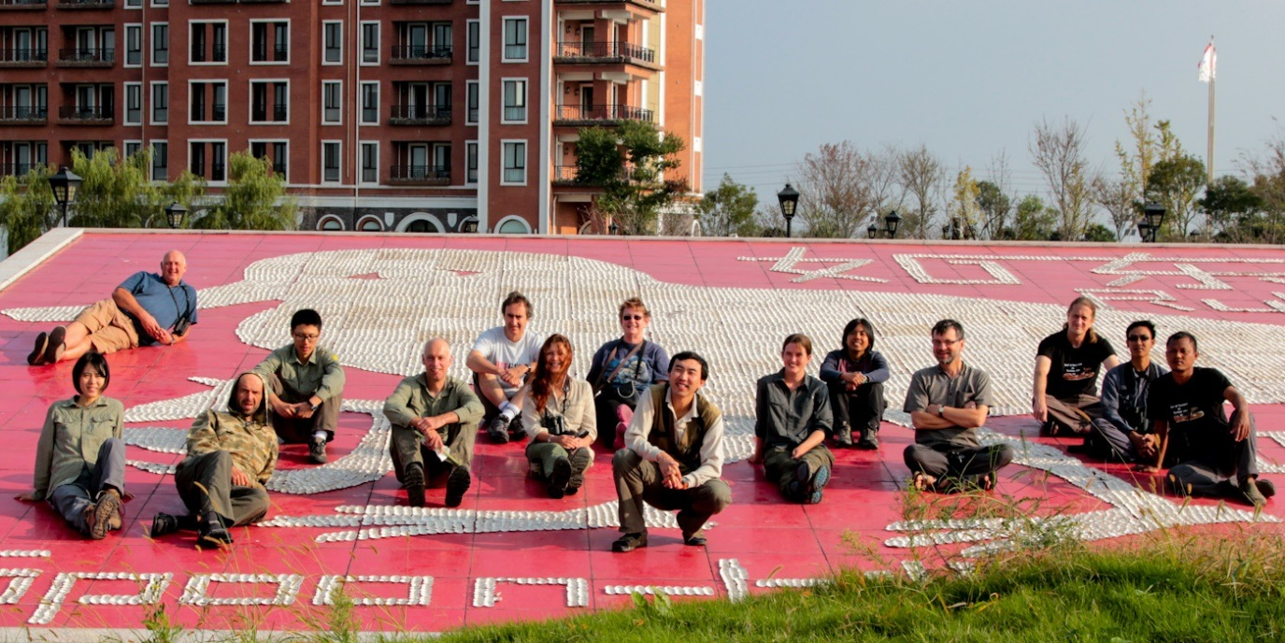
International survey team at the model Spoon-billed sandpiper at Links Hotel, who sponsored SBS in China Photo T. Noah
SBS in the Rudong mudflats
A total of 175-190 birds have been recorded at four sites along the 150 km long coastal stretch with intertidal mudflats. The Tiaozini mudflats in Dongtai County appeared to be the most important with a max of almost 100 birds only here, similar to the September Survey. In total 16 different individually flagged birds were recorded, often multiple times, allowing analyses on sight faithfulness and possibly another global population estimate, currently not exceeding 350-500 birds. Among the flagged birds were at least two juveniles form the head–starting programme on the breeding grounds in Chukotka and another wild bred juvenile from this year as well as a bird marked on migration in Kamchatka! The overall number of juvenile birds was higher compared to last year, suggesting that the site is equally important for adult birds as well as for juveniles. The famous ‘Monument’ bird (see below) was
‘01’ striding confidently forward in Yankiau, Rudong Photo B. Scampion
recorded several times at exactly the same place as last year and seen over a period of 5 weeks!

The Rudong mudflats host up to 100,000s of shorebirds and gulls. Dunlin with 30,000 individuals is the second most common after the Kentish Plover. Bar-tailed Godwits and Red Knots are low in numbers in October but reach over 10,000 birds and 1,500 respectively in spring. Among other globally threatened birds Nordmann’s Greenshank was present in good numbers of over 800 birds and Saunders Gull numbered over 3000 in total. Other birds of note were 24 Dalmatian Pelicans and over 100 Black-faced Spoon-bills.
1000s of dead birds
Right in the middle of the High Tide Roost of the most important stop over site for the species in the Tiaozini Sandbanks more than a thousand dead birds were encountered. Some were already several weeks old, other still alive but moribund and dying. Incidents of dead birds were first noticed in August involving a few sandpiper and mostly wagtails. Poisoned bait was found near-by. In September at the same site more than 130 birds, mostly Red necked Stints, but also six Dunlins and other shorebirds were found dead or dying. In October a total stretch of more than 12 km was searched at high tide with more than 1000 dead birds involving over 30 taxa, including Japanese Quails herons and even passerines. Unfortunately, there were also two dead Spoon-billed sandpiper found, one freshly dead and the other one a fortnight old. Both birds were taken for analyses, as were other birds, but no results have yet come through and it is very concerning that we still don’t know the reason for so many dying birds among the most important High Tide Roost of the Spoon-billed sandpiper
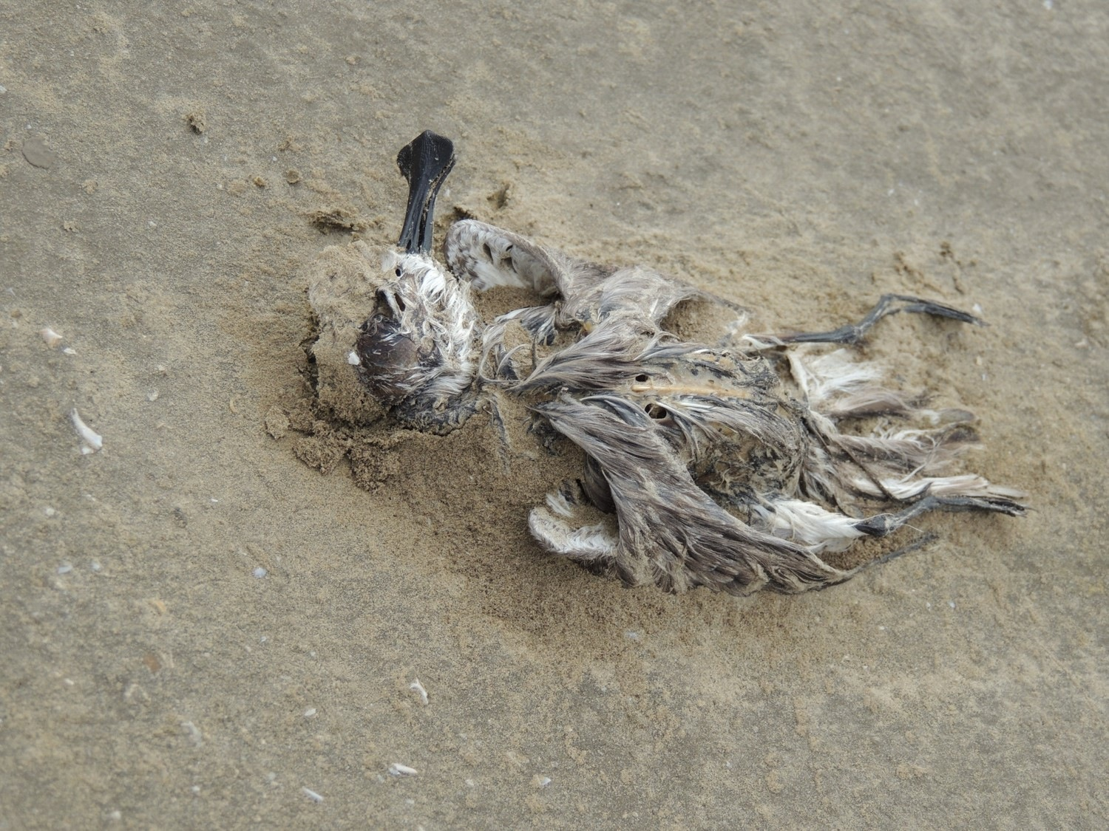
One of two dead birds found in the Tiaozini sandbanks Photo Jing Li
Authorities were alerted but did not seem to be committed and interested in pursuing the case. Although there is little evidence in September and October, still bait poisoning might play a major role, as found in August. No real tissue sample were taken to inquire the real reasons for the mass dying of birds. This is very worrying as the majority of the roosting birds at High Tide use this area.
At a meeting with the Jiangsu Forest Bureau and Nantong Government we raised the issue and the urgency. Immediate action was promised by the authorities. Follow up is initiated and any report will be immediately forwarded.

Conservation challenge
During a meeting with the Jiangsu Forest Bureau, the Rudong and Nantong Government on 13th October, the three previously announced protected areas were reiterated. The exact boundaries are still pending and collaboration with SBS in China and Nanjing Normal University is anticipated. However, the most important Tiaozini mudflats are difficult to protect as they are currently included in a huge 5-year reclamation plan with the development of Deep Sea port facilities converting ca. 60,000 ha mudflats for industrial and agricultural development. Regardless of this development prospect SBS in China along with international support of the SBS TF and other global organisations such as WWT and WWF is launching a campaign aiming to halt or delay the reclamation plans. Other areas are also threatened by reclamation though not immediately. Those areas defined for protection could serve a home for many shorebirds by the invasive Spartina grass is encroaching suitable habitats fast.

Together with Links Hotel ( http://www.linkshotel.cn/ ）in Yangkou SBS in China started a successful campaign to raise awareness of the Spoon-billed Sandpiper and its habitats. A huge banner and t-shirts highlighted the SBS events in October, accompanied by several public lectures. A brochure in collaboration with the Links Hotel to promote eco-tourism is planned among many other things.
The Rudong survey and meetings have been supported by the Manfred-Hermsen Foundation, the US FWS, Mac Arthur Foundation, the RSPB and the Yangtong Company through its Links Hotel

Jing Li (SBS in China) & Christoph Zöckler (SBS TF Coordinator), 29 October 2014

